**EEE361**

**ASSIGNMENT**

**SET-12**

1. Given that F = x2yax – yay, Find

a. $\oint_{L}{F∙dl}$ where L is shown in figure below

b. $\oint_{L}{(∇× F)∙ dS}$ where S is the area bounded by L

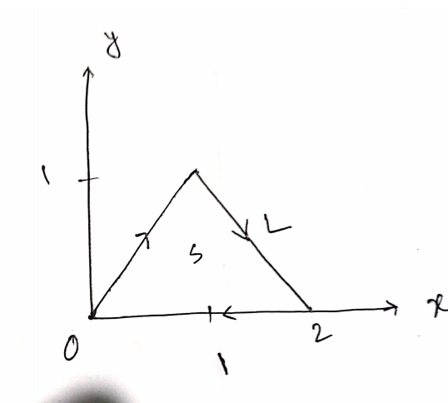

Fig: Problem 1

1. For time varying fields: Find which if the following equations are not satisfy Maxwell’s Equation. Also state why the expression/s don’t satisfy Maxwell’s Equation? (Show Calculation)
$∇∙J + \frac{∂ρ_{v}}{∂t} = 0$

$∇∙D = ρ_{V}$

$∇∙ E = - \frac{∂B}{∂t}$

$\oint{H∙ dl} = \int{(σE + ε\frac{∂E}{∂t}} ) ∙ dS$

$\oint{B∙dS} = 0$

2. Show that in a pure dielectric medium the E field $\vec{E} = 100 sin ( {10}^{8}t + \frac{x}{\sqrt{3}})$ is a valid solution to the wave equation. Also find the dielectric constant (Assuming the permeability is µ0) and the velocity of propagation.
3. In a dielectric medium (ε = 9 ε0, µ = µ0), a plane wave with

$$H = 0.2 cos ({10}^{9}t- kx-k\sqrt{8z} ) a_{y} A/m$$

Is incident on an air at z = 0 find

a. $θ_{r} and θ_{t}$

b. k

c. The Incident **E**

d. The transmitted and reflected **E**

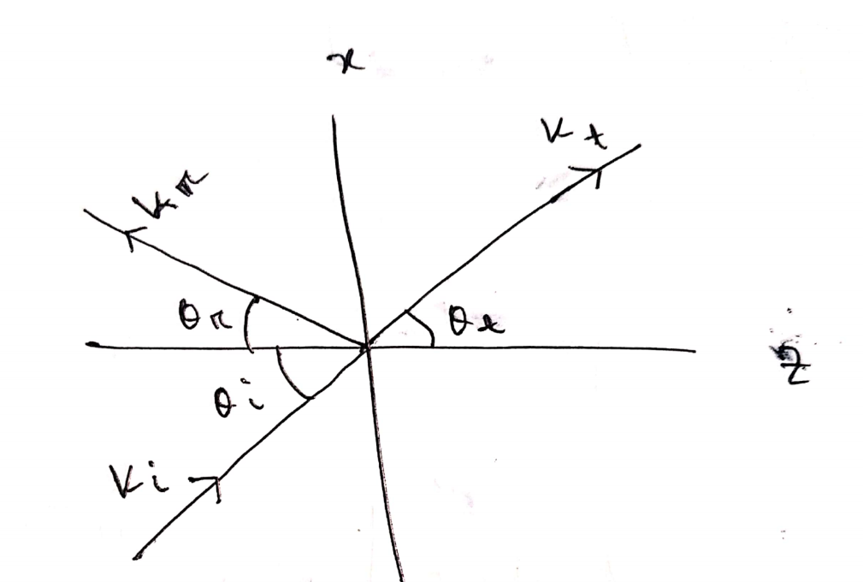

Fig: Problem 4

5. a. Explain the physical meaning of E = - $∇ V$.

To verify that E = yzax + xzay+ xyaz  V/m is truly an electric field, show that

b. $∇ × E = 0$

c. $\oint_{L}{E∙ⅆl}$ = 0, Where L is the edge of the square defined by 0 < x, y < 2, Z =1.